Software Requirements Specification

for

Intelligent Energy Scenario Analysis (IESA)

Version 1.0

Prepared by

Group Name: C1

|  |  |  |
| --- | --- | --- |
| M.Suffian Tafoor | F21-BSSE-138 | Muhammad.suffian.5959@gmail.com |
| M.Farzam Baig | F21-BSSE-136 | farzambaig2016@gmail.com |
| M.Yasir Khan | F21-BSSE-139 | yasirkhandps7@gmail.com |

|  |  |
| --- | --- |
| Supervisor: | Dr. Shaheen |
| Coordinator: | Dr. Sajid Ali khan |
| Date: | 21-11-2024 |

|  |  |
| --- | --- |
|  |  |

Contents

Contents ii

Revisions iii

1 Introduction 1

1.1 Document Purpose 1

1.2 Product Scope 1

1.3 Intended Audience and Document Overview 1

1.4 Definitions, Acronyms and Abbreviations 2

1.5 Document Conventions 2

1.6 References and Acknowledgments 2

2 Overall Description 3

2.1 Product Perspective 3

2.2 Product Functionality 4

2.3 Users and Characteristics 4

2.4 Operating Environment 4

2.5 Design and Implementation Constraints 5

2.6 User Documentation 5

2.7 Assumptions and Dependencies 5

3 Specific Requirements 7

3.1 External Interface Requirements 7

3.2 Functional Requirements 9

3.3 Behaviour Requirements 10

4 Other Non-functional Requirements 12

5 Other Requirements 13

Appendix A – Data Dictionary 14

Appendix B - Group Log 15

Revisions

| Version | Primary Author(s) | Description of Version | Date Completed |
| --- | --- | --- | --- |
| Version 1.0 | Muhammad Farzam Baig Muhammad Suffian Tafoor  Muhammad Yasir Khan | Completed full SRS | 15/10/2024 |
| Version 1.1 | Muhammad Farzam Baig Muhammad Suffian Tafoor  Muhammad Yasir Khan | Accommodate changes recommended by Supervisor | 18/10/2024 |
| Version 1.2 | Muhammad Farzam Baig Muhammad Suffian Tafoor  Muhammad Yasir Khan | Revised Chapter 1 and switched from OOP to Structural programming approach | 22/10/2024 |
| Version 1.3 | Muhammad Farzam Baig Muhammad Suffian Tafoor  Muhammad Yasir Khan | Revised chapter 2 and chapter 3 | 28//102024 |
| Version 1.4 | Muhammad Farzam Baig Muhammad Suffian Tafoor  Muhammad Yasir Khan | Revised chapter 4 and 1  And given finishing touch for FYP-1 | 31/10/2024 |

# Introduction

Intelligent Energy Scenario Analysis (IESA) is an AI based business intelligence project that will revolutionize energy scenario analysis by utilizing **WisRule,** Linear regression, K Means Clustering etc. This would help in understanding different demand profiles, identifying inefficiencies, and targeting energy-saving interventions more effectively. IESA aims to predict future scenarios related to energy, such as gas and electricity production and consumption, as well as associations between energy import, generation, and production etc. IESA provides users with comprehensive business intelligence on total energy management, IESA is a DSS (Decision Support System) which enables optimal decision-making for sustainability and cost efficiency. The project will analyze historical energy data to predict future needs and offer personalized recommendations, helping users to take better future decisions

In the following section, readers will find detailed information about IESA, its key functionality, technology and architecture and also its core features, user interfaces, functional requirements and non-functional requirements. Additionally, we will also explain **WisRule algorithm** and how it will be used for prediction.

## Document Purpose

This document outlines the software requirements for the Intelligent Energy Scenario Analysis (IESA) system, an application designed to analyze energy consumption and production patterns. Version 1.0 is the initial release version.

## Product Scope

Intelligent Energy Scenario Analysis (IESA) is a sophisticated business intelligence project designed to enable user to optimize gas and electricity usage. By helping to reduce energy wastage, lower costs, and contribute to a greener future on a national scale, IESA offers an impactful solution for sustainable energy management. The software utilizes historical data and employs the **WisRule** algorithm to analyze and visualize patterns of energy production and consumption related scenarios, providing predictive insights, while **K-Means Clustering** will be used for grouping data based on similar consumption patterns, and **Linear Regression** will be used for forecasting energy usage and predicting future energy trends. IESA aims to predict future scenarios related to energy, such as gas and electricity production and consumption, as well as associations between energy import, generation, and production etc.

## Intended Audience and Document Overview

This Following table highlights Intended Audience:

**Table 1.3: Table for Audience and their type**

|  |  |  |
| --- | --- | --- |
| ID | Stakeholders | Type |
| ST01 | Our FYP group | Technical member |
| ST02 | Supervisor | Technical Team |
| ST03 | Co-Supervisor | Technical Team |
| ST04 | Evaluators | Technical Team |
| ST05 | Input Entry Operator | End User |
| ST06 | Energy Planner | End User |

This SRS has 4 chapters (5 is optional) chapter 1 is the starting point which contains product introduction scope etc. and readers should start from chapter 1 and go through each chapter one by one until chapter 4. Chapter 2 is overall description from product perspective to operating environment and users etc. Chapter 3 focus on specification requirement which includes different interfaces functional requirement and behaviour requirement. Chapter 4 focus on Nonfunctional Requirement

## Definitions, Acronyms and Abbreviations

**Table 1.4: Table for Definations,Acronyms and Abbreviations**

|  |  |  |
| --- | --- | --- |
| ID | Acronyms | Abbreviations |
| AC01 | **AI** | Artificial Intelligence |
| AC02 | **IESA** | Intelligent Energy Scenario Analysis |
| AC03 | **DSS** | Decision Support System |

## Document Conventions

The documents adheres to the IEEE formatting requirements and the following are the typographical conventions followed:

* **Font and Size**: We have used **Arial** font with **size 11** for readability.
* **Headings**: Headings are formatted in **Arial size 14** and the text style used is **bold** to differentiate them clearly from the body text.
* **Comments**: Comments are written in **italic** text style to differentiate them from the main content.
* **Highlighted Text**: Important points within paragraphs are highlighted by using **bold** text style.

## References and Acknowledgments

|  |  |  |
| --- | --- | --- |
| [1] |  | U. o. Bath, "IEEE Style Guide," 2017. [Online]. Available: https://www.bath.ac.uk/publications/library-guides-to-citing-referencing/attachments/ieee-style-guide.pdf. [Accessed 16 October 2024]. |
| [2] |  | D. M. Shaheen, "WisRule: First cognitive algorithm of wise association rule mining," 2022. [Online]. Available: https://www.researchgate.net/publication/361788259_WisRule_First_cognitive_algorithm_of_wise_association_rule_mining. [Accessed 2024]. |

# Overall Description

## Product Perspective

The IESA is a **new and self-contained** product which aims at analyzing historical data of gas and electricity and makes patterns and based on those patterns it predict future energy production and consumption, as well as associations between energy import, generation, and production. It is processed using **WisRule, Linear Regression** and **K Means Clustering etc**. The goal is to provide insights and predictions about future energy needs which should contribute to reducing energy waste or downtime and cut costs.

The below is a general Diagram that illustrates how our product works:

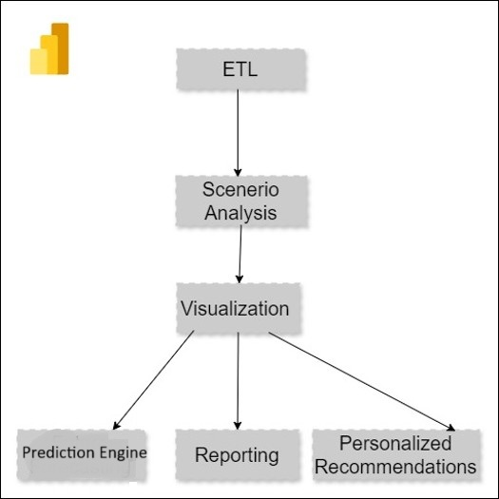

**Figure 2.1:Context Diagram**

## Product Functionality

This table describes the functionality of the IESA:

**Table 2.2: Features of the system**

|  |  |  |
| --- | --- | --- |
| ID | Feature | Description |
| FT01 | Energy Data Acquisition | This feature interacts with user to get input data from user through csv/xml. |
| FT02 | Energy Data Storage | This units extracts data from csv/xml inputted by user and stores in Database. |
| FT03 | ETL | This Module extracts data from database transforms it and loads into our system. |
| FT04 | Scenario Analysis | The system must analyze historical data and generate patterns for production and consumption, as well as associations between energy import, generation, and production etc. |
| FT05 | Prediction Engine | The system must use WisRule, Linear Regression, K Means Clustering for prediction based on different scenarios |
| FT06 | Data Visualization | The system must visualize both historical data and predicted data on dashboard using graphs and charts. |
| FT07 | Reporting | The system must allow to share and print reports both in hard and soft form. |
| FT08 | Personalized Recommendations | The system must provide user with recommendations for future decision based on historical and predicted data. |

## Users and Characteristics

The following table highlights user and their characteristics for IESA:

**Table 2.3: Table for user and their characteristics**

|  |  |  |
| --- | --- | --- |
| ID | User | Characteristics |
| U01 | Input Entry Operator | Input Entry operator will input historical production and consumption, as well as associations between energy import, generation, and production. |
| U02 | Energy Planner | Energy planner will analyze historical data and predicated data displaced on dashboard and will make future plans and take decision. |

## 

## Operating Environment

The following table highlights constraints for IESA:

**Table 2.4:** **Table for operating Environment**

|  |  |  |
| --- | --- | --- |
| Specification | Minimum | Recommended |
| Ram | 8GB RAM | 16GB RAM |
| Storage | 6GB free | 10GB or more depending on Data Size |
| CPU | 2 cores | 4 or more Cores |
| OS | Windows 7 | Windows 10 or 11 |
| Python | Any latest version | Any latest version |
| Database | MS SQL latest version | MS SQL latest version |

## Design and Implementation Constraints

The following table highlights constraints for IESA:

**Table 2.5: Table for Design and implementation constraints**

|  |  |  |
| --- | --- | --- |
| ID | Constraint | Description |
| S01 | Scope | The scope is limited to associative mining and predicting production and consumption related scenarios of gas and electricity only. |
| S02 | Tools | The system must have tools like Python for data processing and MS SQL for database. |
| S03 | Processing capabilities | The system should support concurrent processing for multiple scenario analyses running simultaneously. |
| S04 | Cost | The Cost should cater both cost of Research and development, Deployment and maintenance |

## 

## User Documentation

The following user documentation will be delivered:

* **User Manual**: A detailed guide covering system setup, energy data import, and usage of key features like scenario analysis and prediction.
* **Quick Start Guide**: A shorter version to help new user get started quickly.
* **Tutorials**: Step-by-step video or text tutorials to demonstrate the core functionalities will also be provided or uploaded on YouTube.

## Assumptions and Dependencies

The following table highlights assumptions and Dependencies:

**Table 2.7: Table for Assumption and Dependencies**

|  |  |  |
| --- | --- | --- |
| Sr No. | Assumptions | Dependencies |
| *1* | It is assumed that Input Entry Operator knows how to input data without any issue or error | The system is depended on Database for data management |
| *2* | It is assumed that energy planner will not only reply on systems prediction but will also use his own experience for decision making | The accuracy of system depends on the accuracy/quality of Data inputted. |
| *3* | It is assumed that user has accurate historical data of gas and electricity | The improvement of system relies on feedback from user |

# Specific Requirements

## External Interface Requirements

### User Interfaces

The IESA system offers a user-friendly interface designed for energy planners, Input Entry Operator. The user interface (UI) will feature the following main screens:

**Figure 3.1.1: Electricity Dashboard**

**Figure 3.1.3: IESA main Dashboard**

**Figure 3.1.2: Natural Gas Dashboard**

### Hardware Interfaces

The following table highlights Software Interfaces for IESA:

**Table 3.1.2 Table for Hardware Interfaces**

|  |  |
| --- | --- |
| Hardware | Description |
| Printer | It will be required to print the energy scenario reports. |
| Monitor | It will be required to display energy visualization dashboard. |

### Software Interfaces

The following table highlights Software Interfaces for IESA:

**Table 3.1.3: Table for Software Interfaces**

|  |  |
| --- | --- |
| Software | Description |
| Power BI | It is business intelligence tool that allow you to visualize your data and generate insights |
| Microsoft Visual Studio Code | It is source code editor that provides support in debugging, syntax highlighting and intelligent code compilation |

### Communications Interfaces

The following table contains communication interface for IESA system:

**Table 3.1.4: Table for Communication Interfaces**

|  |  |
| --- | --- |
| Communication Interfaces | Description |
| Local Database Interaction: | The IESA system uses MS SQL for structured data management. It handles energy data storage, updates, and querying locally. |
| Monitor | The IESA system uses monitors connected with DVI, HDMI or using another connector |

## Functional Requirements

The following table highlights Functional Requirements for IESA:

**Table 3.2: Table for Functional Requirements**

|  |  |  |
| --- | --- | --- |
| ID | Description | Feature |
| FR01 | The system shall allow user to input historical data in form of csv/xml. | FT01 |
| FR02 | The System shall store input data in database. | FT02 |
| FR03 | The System shall extract data from database clean it and prepare it and load it into system | FT03 |
| FR04 | The system shall analyze historical data and generate patterns for different energy scenarios. | FT04 |
| FR05 | The system shall use **WisRule, K mean cluster, Linear Regression** and other algorithms to predict future energy related scenarios. | FT05 |
| FR06 | The system shall visualize both historical data, different scenarios and predicted data on dashboard using graphs and charts. | FT06 |
| FR07 | The system shall allow to share and print reports both in hard and soft form. | FT07 |
| FR08 | The system shall provide user with recommendations for future decision based on historical and predicted data. | FT08 |

## Behaviour Requirements

### DFD View

**Actors:**

* Energy Planner
* Input Entry Operator

**Figure 3.3.1: Data flow Diagram level 0**

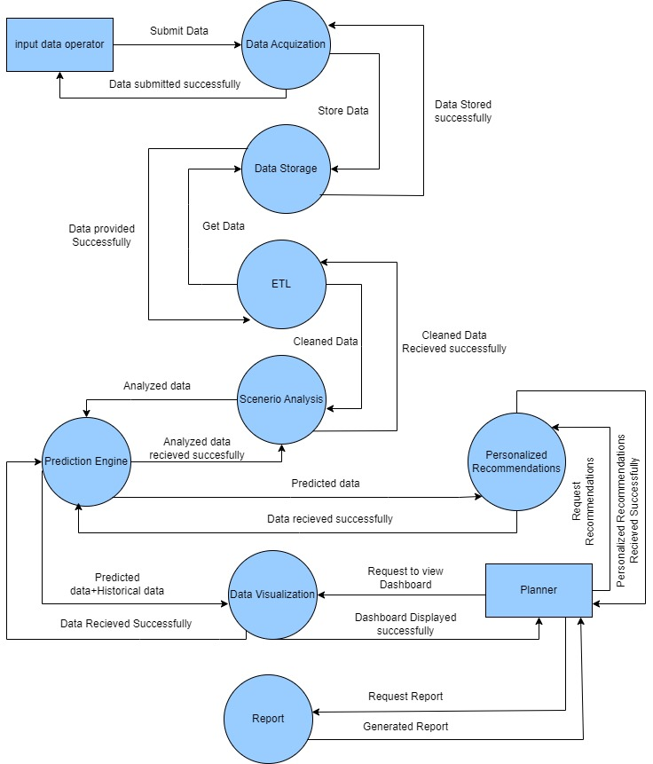

**Figure 3.3.2 Data flow Diagram level 1**

# Other Non-functional Requirements

The following table highlights Nonfunctional Requirements for IESA:

**Table 4.1: Table for Nonfunctional Requirements**

|  |  |  |
| --- | --- | --- |
| ID | NFR | Statement |
| NFR01 | Response Time | The system should generate energy scenario report with in 15 seconds after user input’s data. |
| NFR02 | Performance | The system should be able to handle up to 10 parallel user without and performance degradation. |
| NFR03 | Availability | The system should be available for user’s 24/7 |
| NFR04 | Ease of use | Thes system should allow user to perform most of the functionality within 5 minutes of first use |
| NFR05 | Maintainability | The system should be modular and well documented with easily updateable and maintainable components |

# Other Requirements

<This section is **Optional.** Define any other requirements not covered elsewhere in the SRS. This might include database requirements, internationalization requirements, legal requirements, reuse objectives for the project, and so on. Add any new sections that are pertinent to the project.>

Appendix A – Data Dictionary

**Table 6.1: Table for Data Dictionary**

|  |  |  |  |  |
| --- | --- | --- | --- | --- |
| **Name** | **Type** | **Description** | **States** | **Operations/Requirements** |
| **Input Data Operator** | Entity | Input data operator is responsible for data input | N/A | Submits energy Data |
| **Energy Planner** | Entity | Utilized reports recommendation and insights through dashboard | N/A | Receives visualization reports and recommendations for decision making. |
| **Data Acquisition** | Process | Get input Data from input data operator | Active/  Inactive | Gets data from users and stores in Database |
| **Data Storage** | Process | Stores the acquired data in database. | Active/  Inactive | Stores data in Database |
| **ETL Process** | Process | Extracts\loads data from Database cleans and prepares data | Active/  Inactive | Extracts data from database, Cleans and prepares data |
| **Scenario Analytics** | Process | Gets cleaned data  And analysis it. | Active/  Inactive | Analysis of different scenarios from cleaned data |
| **Prediction Engine** | Process | Gets analysis and data from scenario analysis and predicts future. | Active/  Inactive | Uses AI algorithm like **WisRule** and others for prediction |
| **Data Visualization** | Process | Visualized historical data and predicted data on dashboard | Active/  Inactive | Creates a Dashboard with charts and bars etc. and Visualizes data |
| **Reporting** | Process | Generates reports | Active/  Inactive | Generate Soft copy or Hard copy reports |
| **Personalized Recommendations** | Process | Provides recommendations based on predicted data | Active/  Inactive | Generates Recommendation based on prediction for Data Planner |

Appendix B - Group Log

**Table 7.1: Table for group log**

|  |  |  |  |  |
| --- | --- | --- | --- | --- |
| **Serial Number** | **Meeting Date** | **Meeting Attendees** | **Location** | **Minutes** |
| 1 | 7/10/2024 | Muhammad Suffian  Muhammad Yasir Muhammad Farzam Muhammad Shaheen | In University | Discussed The idea and project scope of IESA also given shown some samples dashboard to Sir Shaheen |
| 2 | 16/10/2024 | Muhammad Suffian  Muhammad Yasir Muhammad Farzam | Online | Discussed WisRule algorithm and other Features od IESA |
| 3 | 22/10/2024 | Muhammad Suffian  Muhammad Yasir Muhammad Farzam Muhammad Shaheen | In university | Show version 1.2 and asked for improved |
| 4 | 28/10/2024 | Muhammad Suffian  Muhammad Yasir Muhammad Farzam Muhammad Shaheen | In university | Shown version 1.3 and asked for improved |
| 5 | 31/10/2024 | Muhammad Suffian  Muhammad Yasir Muhammad Farzam | online | Discussed SRS v1.4 and gave finishing touch |
| 6 | 21/11/2024 | Muhammad Suffian  Muhammad Yasir Muhammad Farzam Muhammad Shaheen | In university | Discussed final SRS and got approval from Dr Shaheen |

**Table 7.2: Work Division**

|  |  |  |
| --- | --- | --- |
| **SRS Documentation Contribution** | **Member** | **Work Done** |
| Muhammad Suffian Tafoor | Chapter 3 & 2 (Product Functionality & operating environment) |
| Muhammad Farzam Baig | Chapter 1 and 4 |
| Muhammad Yasir Khan | Chapter 2 & 3 (User Interfaces) |